Query is used to fetch Data. It is like GET.

Mutation is used to modify data

Graph QL uses type as follows:

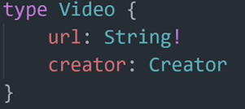 This is to define data type

This is the query:

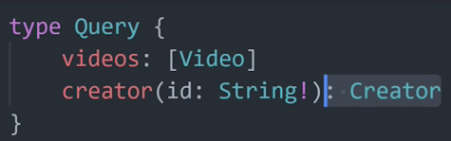

Mutation to modify:

